SWDBS401– BACKEND SYSTEM DESIGN
DATE: Wednesday, 11/June/2025
PERIOD: 8.30 AM-11.30 AM


END OF TERM III EXAMINATIONS SCHOOL YEAR: 2024/2025
KIREHE ADVENTIST TVET SCHOOL(APAPEN)
SECTOR: ICT and MULTIMEDIA RQF LEVEL: L4
TRADE: SOFTWARE DEVELOPMENT MARKS: CAMIS:
…………/100
…………/80

DURATION: 3 HOURS

INSTRUCTIONS TO CANDIDATES:
This Exam paper is composed of Three Sections (A, B, C). Follow the instructions given below, and answer the indicated questions for a total of
100 marks
Section A: Seventeen (17) questions, all Compulsory
55 marks
Section B: Among the five (5) questions, attempt any three (3) 30 marks
Section C: Among the two (2) questions, attempt any one (1)
15 marks
Allowed materials:
- Ruler ,Blue or Black pen

SECTION A: Attempt all questions (55 marks)
KIREHE ADVENTIST TVET SCHOOL(APAPEN)

01. | A framework is a structured platform or foundation used to build and develop software applications. It provides a set of tools, libraries, and best practices that help developers streamline their work, ensuring consistency, efficiency, and maintainability. Answer the following question by indicating True or False in the blank spaces provided  - Laravel is a PHP framework. True /1mark  - Symfony is a full-stack PHP framework. False  /1mark  - CodeIgniter must be installed using the command- line interface. False /1mark  - Yii is used to develop large-scale web applications.  True /1mark |  |  |  |  | (4Marks)
02. | Answer the following question by indicating True or  False in the blank spaces provided  - The SDLC has multiple phases including planning and maintenance. True /1mark  - Requirements gathering is a phase in the SDLC.  False /1mark  - The maintenance phase of SDLC includes making updates to released software. True /1mark |  |  |  |  | (3Marks)
03. | Match each ERD symbol with its correct name: |  |  |  |  | (3Marks)
 |  |  | Symbol | Name

 |  | 1…. | 1. Rectangle | A. Attribute
 |  | 2…. | 2. Ellipse | B. Weak Entity
 |  | 3…. | 3. Double Rectangle | C. Entity
04. | Which of the following technique used in Structured Systems Analysis and Design Method (SSADM)?  /2Marks  - Agile Methodology  - Entity-Relationship Diagrams (ERDs)  - Research methodology  - User Stories |  |  |  |  | (2Marks)
05. | Answer the following question by indicating True or False  in the blank spaces provided  - Graphics Processing Unit (GPU) True /0.5mark  - Cooling Systems True /0.5mark  - Expansion Cards True /0.5mark  - Monitor False /0.5mark |  |  |  |  | (2Marks)
06. | Which of the following is a type of relationship in a database?  a. One-to-One |  |  |  |  | (3Marks)
KIREHE ADVENTIST TVET SCHOOL(APAPEN)

- Many-to-Many
- Single-Value
- One-to-Many

07. | Which one (1) of the following is NOT a type of user documentation?  - User Manuals  - Installation Guides  - API Documentation  - Technical Specifications  - Online Help Systems | (2Marks)
08. | API is a set of rules and protocols that allows different system applications to correspond with each other.  - What does API stand for?  - Application Programming Interface  - Advanced Programming Interface  - Automated Programming Integration  - Application Protocol Interface  - Which of the following is an example of an API?  - A database management system  - A social media sharing feature  - A weather data service that provides information upon request  - An operating system | (3Marks)
KIREHE ADVENTIST TVET SCHOOL(APAPEN)

- What is the primary purpose of an API?

  - To provide a user interface for applications
  - To allow different software applications to communicate
  - To store data securely
  - To enhance graphics in applications

09. | The V-Shape Model is a software development process that emphasizes a structured approach to development and testing.  Match the Key Features of V-Shape Model with Their Descriptions |  |  |  |  | (4Marks)
 |  |  | Feature | Description
 |  | 1….. | 1. Phases of coding | A. Documentation is produced at each phase to aid in  testing.
 |  | 2….. | 2. Verification and Validation | B. Each development phase has a corresponding testing  phase.
 |  | 3….. | 3. Sequential Flow | C. Ideal for projects with well-defined requirements, ensuring clarity and  quality.
 |  | 4….. | 4. Documentation | D. The model follows a structured sequence where one  phase must be
KIREHE ADVENTIST TVET SCHOOL(APAPEN)

completed before the
next begins.
10. | UML is a powerful tool for software development, providing a comprehensive framework for modeling systems and fostering better collaboration among project stakeholders.  - What does UML stand for?  - Universal Modeling Language  - Unified Modeling Language  - Unified Method Language  - Universal Method Language  - Which of the following is a type of structure diagram in UML?  - Data Flow Diagram  - Sequence Diagram  - Class Diagram  - Activity Diagram  - What is the primary purpose of UML?  - To write code for software applications  - To visualize, specify, construct, and document software artifacts  - To manage project timelines  - To perform software testing |  |  |  |  | (3Marks)
KIREHE ADVENTIST TVET SCHOOL(APAPEN)

11. | Application software refers to programs designed to perform specific tasks or applications for end users.  Match the Application Software with its Description  Ans Software Description  1….. 1.Word Processor a. Software used for  creating spreadsheets and data analysis.  2….. 2. Spreadsheet b. Software designed  for managing and organizing email communications.  2…… 3.Database c. Software used for Management System creating text document (DBMS) such as reports and  letters.  4….. 4. Email Client d. Software that allows  the creation, organizati and manipulation of databases. |  |  |  |  | (4Marks)
12. | User documentation is a collection of materials designed to assist end-users in understanding and effectively using a software application or system. A table below explains user documentation  Match the items in Column A with the correct descriptions in Column B. |  |  |  |  | (5Marks)
 |  | Answer | Column A | Column B
 |  | 1…. | 1. Purpose of Documentation | A. Provides detailed information about
KIREHE ADVENTIST TVET SCHOOL(APAPEN)

 |  |  |  | system architecture.
 |  | 2…. | 2. Primary Audience | B. Designed to help end- users effectively use the  system.
 |  | 3…. | 3. Content Focus | C. Targeted at software developers and IT professionals.
 |  | 4…. | 4. Examples | D. User manuals, tutorials, and FAQs.
 |  | 5…. | 5. Details Included | E. Emphasizes practical use and troubleshooting.
13. | Many people think of JSON (JavaScript Object Notation) as a language, but it’s really just a data interchange format that works natively with most modern languages, like Python, Java, PHP, and JavaScript.  Put the following table in JSON format. |  |  |  |  | (3Marks)
KIREHE ADVENTIST TVET SCHOOL(APAPEN)
Student _ Information
Name | Age | Dept | Hobbies | IsClassLeader | Telephone
Joe | 16 | Computer | Dance, Books, Public Speaking, Golf | False | 2590778812

14. | Match each category of software with the correct example: Answer Software Example  1…… 1.System Software A. RabbitMQ  (Message Broker)  2…… 2.Application B. Firmware in Software washing machines  3…… 3.Development C. Microsoft Office Software Suite  4….. 4. Embedded D. Integrated Software Development  Environment (IDE) like Visual Studio  5….. 5.Middleware E. Windows Operating System | (5Marks)
15. | The following are three(3) relations:  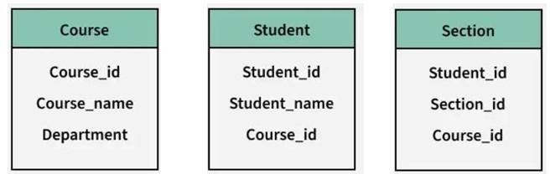 | (3Marks)
KIREHE ADVENTIST TVET SCHOOL(APAPEN)

- List primary keys in the above relations

- Among relations is there a weak?, if yes which one

- Apply relationship among relations

16. | you are tasked with designing the physical data model for a new database. Apply your knowledge to complete the following statements:/ 1mark  - In a physical data model, the defines how data is stored in a database, including the specific data types for each column. / 1mark  - The use of in a physical data model helps improve query performance by allowing faster access to rows in a table. / 1mark  - A key in a physical data model establishes a link between two tables, ensuring referential integrity. / 1mark  - The process of involves dividing a large table into smaller, more manageable pieces to optimize performance and manageability. / 1mark | (4Marks)
KIREHE ADVENTIST TVET SCHOOL(APAPEN)

17. | A logical data model is a structured representation of data that outlines how data is organized, related, and processed within a system, without focusing on the physical aspects of data storage  Match the following logical data model concepts (Column A) with their practical applications or scenarios (Column B)  Answer Column A Column B (Concepts) (Applications/Scenarios)  1….. 1. Entity A. Connects the customer  entity to the orders entity in a database.  2….. 2. Attribute B. Ensures that each record  in a student table can be uniquely identified.  3….. 3. Relationship C. Used to identify and  represent customers in a sales database.  4….. 4. Primary Key D. Determines the age of a  customer in a customer information table. | (2Marks)
KIREHE ADVENTIST TVET SCHOOL(APAPEN)

Section B: Attempt any three (3) questions (30 marks)
KIREHE ADVENTIST TVET SCHOOL(APAPEN)
Attributes | Description | Example value
PositionX | The x coordinate of the game element. | 92
PositionY | The y coordinate of the game element. | 106
Width | The width of the game element. | 150
Height | The height of the game element. | 200
ImageFilename | The filename of the image file for the game element. | GameElement Frame1.png

18. | Analyze the following Scenario and answer related questions:  A computer game is being developed using object-oriented programming. The following image is a screenshot from the game.  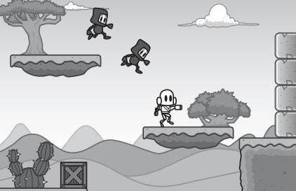  There are scenery elements and animated elements. The player’s character is one of the animated elements.  Each game element has the attributes:  Each game element has a method, GetDetails() that returns a string containing all the element’s attributes. | (10marks)

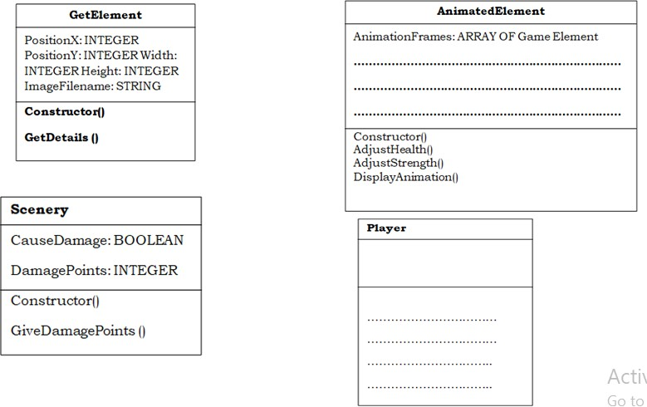
The player’s character is one of a number of animated elements. All animated elements have the attributes:

Attributes | Description | Example value
AnimationFrames | An array of GameElement
Direction | A string giving the direction the object is travelling in. | "Left"
Strength | A value for the strength that indicates the power of the object. | 2000
Health | A value for the health that indicates the health of the object. | 100

The player’s character can either move left or right, or
KIREHE ADVENTIST TVET SCHOOL(APAPEN)
jump.
a. Complete the following class diagrams for the game
You do not need to include any additional get or set methods. / 7marks

- Name the parts a class diagram below: / 3marks
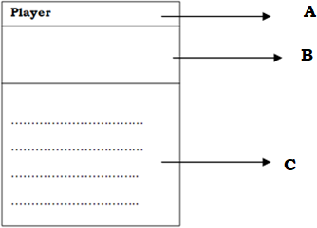

19. | A Level 0 Data Flow Diagram (DFD), also known as a context diagram, provides a high-level overview of a system and its interactions with external entities. It serves as the top-level representation of the system's data flows, illustrating how information moves between the system  and outside entities without delving into internal | (10marks)
KIREHE ADVENTIST TVET SCHOOL(APAPEN)

processes.
- Analyze the purpose of a context diagram within system design. What key elements does it illustrate, and how do they interact with the system?
- Examine the implications of missing external entities in a context diagram. What potential issues could arise from this omission?
- Compare the context diagram with a data flow diagram (DFD Level1). How do the two differ in their focus and level of detail?

KIREHE ADVENTIST TVET SCHOOL(APAPEN)

20. | Analyze how the effectiveness of system documentation and user documentation can impact the overall software development lifecycle. What are the potential consequences of inadequate documentation in both cases? | (10marks)
KIREHE ADVENTIST TVET SCHOOL(APAPEN)

21. | Evaluate the effectiveness of the assembly line testing process described below. Consider the impact of the three test groups  - Group 1: tests to check all dimensions are correct  - Group 2: tests to check strength at various points on the product item  - Group 3: tests to check paint color and coverage  Only if the item passes all three group tests is it accepted. If the Group 1 tests are passed, but exactly one of the other two group tests fails, the item is sent for repair.  Otherwise the item is rejected.  Based on information above complete decision table showing all the possible outcomes and results | (10marks)
KIREHE ADVENTIST TVET SCHOOL(APAPEN)

 | 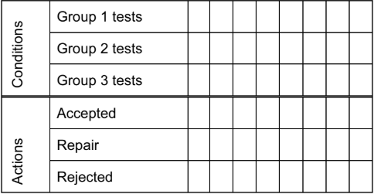
22. | Evaluate the effectiveness of Data Flow Diagrams (DFDs) in representing the flow of data within a system. Consider how well they facilitate understanding of processes, clarify requirements, support system design, and enhance communication among stakeholders. | (10marks)
KIREHE ADVENTIST TVET SCHOOL(APAPEN)

Section C: Attempt only one (1) question (15 marks)
KIREHE ADVENTIST TVET SCHOOL(APAPEN)

23. | Design a comprehensive Library Management System database keeps track of readers with the following considerations:  - The system keeps track of the staff with a single point authentication system comprising login Id and password.  - Staff maintains the book catalog with its ISBN, Book title, price, category, edition, author Number and details.  - A publisher has publisher Id, Year when the book was published, and name of the book.  - Readers are registered with their user_id, email, name (first name, last name), Phone no (multiple entries allowed), communication address. The staff keeps track of readers.  - Readers can return/reserve books that stamps with issue date and return date. If not returned within the prescribed time period, it may have a due date too.  - Staff also generate reports that has readers id, registration no of report, book no and return/issue info.  From above information draw an Entity Relationship Diagram. | (15marks)

24. | An online food delivery service allows users to order food  from various restaurants through a mobile app or website. The system involves several actors and processes, making it suitable for creating a use case diagram.  Actors:  - Customer: The user who orders food.  - Restaurant owner: The food provider fulfilling the order.  - Delivery Person: The individual responsible for delivering the food.  - Admin: The system administrator managing the platform. | (15marks)
KIREHE ADVENTIST TVET SCHOOL(APAPEN)

Use Cases:

- Register Account: Customers can create an account.
- Login: Customers and restaurant owners can log into the system.
- Browse Menu: Customers can view restaurant menus.
- Place Order: Customers can select items and place an order.
- Make Payment: Customers can pay for their orders online.
- Track Order: Customers can track the status of their delivery.
- Update Menu: Restaurant owners can update their menu items.
- Confirm Order: Restaurants can confirm received orders.
- Assign Delivery: Delivery persons can accept and deliver orders.
- Manage Users: Admin can manage customer and restaurant accounts.
From above information draw a use case diagram of above system

KIREHE ADVENTIST TVET SCHOOL(APAPEN)

KIREHE ADVENTIST TVET SCHOOL(APAPEN)

